SIMULATION LOG

Found that the unit of Z is actually omega/cm2 in the original paper, however, the input parameters are also in the unit of cm2, so the numerically simulated values should be the same.

By directly putting in the experimental values into the pero model, the Nyquist plot is obtain to be approximately

Only a very little circle in front and the order of magnitude is way off, comparing to the experimental values,

By changing the voltage to control the magnitude of the circle(voltage = 1.63), the simulated data may be generated as the red dots in the following plot

Clearly, the relative magnitude of the peak of the half circle is wrong as well.

* Going back to the matlab file to see if there is anything wrong with the simulation
  + Graphical user interface

    Description automatically generated
  + The simulation is giving the same result, showing that the simulation itself is correct, something else is incorrect.
* Situation now is that even by directly putting in the experimental data from the paper, the obtained Nyquist plot is not as expected.
  + The height of the half circle doesn’t match
  + The order of magnitude isn’t correct as well
  + Not due to the unit or the simulation being wrong
  + In the range of the provided voltage, the simulated k is not even stablised.
* now try to change the parameters randomly to see which affect which.
* And read the paper to find some clue
* By changing the and investigate I found:
  + Size of circle 2 is controlled by the value of C_b(smaller C_b smaller loop)
  + Completeness and stabilization of k is control by both R_ion and bias voltage
    - Bigger R_ion, the shape is more stabilized with lower bias voltage
  + C_g determines the dip depth of the connection between first and the second circle.
    - Smaller ---- deeper
    - A picture containing chart

      Description automatically generated



* + J_s determines the relative size of the two semicircle ( have a huge general effect).
    - But when increasing it to 6.1e-11, further increase stabilizes the shape
    - Bigger ---- bigger first circle
  + nA does not change the shape of the curve much, but mostly changes the magnitude of the double circle.
* By using customized initial guess, a fit can be obtained as this
  + Chart

    Description automatically generated with low confidence
  + While fitting parameters are
    - C_a 2.03534548e-04,
    - C_b 8.53497697e-05,
    - R_i 2.59998353e+04,
    - C_g 4.04292147e-07,
    - J_s3.36778932e-12,
  + nA 1.39011012e+00
* Now, I want to test the effectiveness of the initial guess finding algorithm by adding a simulated 0V data set with the previously fitted parameters. And directly put in all the data set into the initial_guess and global_fit function
  + It turns out that the 0V data for some reason is completely not consistent with the other set of data
  + Chart, scatter chart

    Description automatically generated
  + The 0V data’s second loop is very big comparing to the first loop and to the other data sets.
  + By changing the value of J_s the relative size of the data could be made normal, as demonstrated by the parameter relation with shape above.
* Now try to put the actual and simulated data set together into the initial guess and global fit function to see if it works.
  + A picture containing chart

    Description automatically generated
  + Chart

    Description automatically generated with low confidence
  + Apparently, the curve is more or less being fitted, the result is not very well though
  + The 0 V data is being fitted well. So if we have a bigger J_s (bigger to e8 or something) and therefore a more reasonable 0V pattern, the fit might work better.
  + The initial guess obtained from the function is actually
    - Text

      Description automatically generated with low confidence
* Added a procedure to sort the dfs by the dataframes’ bias voltage to ensure the finding R and K functions are working correctly.

Interim summary and conclusion

* The experimental data lack 0V data, causing it impossible for me to directly use the initial guess obtaining function
* By using the data in the paper(not directly), an initial fit is obtained. However, there are some problems about the data on the paper, ex. C_a = C_b will make the relative size the same, so I changed some of the parameters to a more reasonable initial guess.
* After obtaining the parameters by the customized initial guess, I used the fitted parameters to generate a set of data for 0 bias voltage.
* Then the simulated data set of 0 voltage is put together with the original experimental data set to form a complete big data set that is eligible for the initial guess obtaining and the global fitting function I wrote before.
* After running the initial guess and global fitting function, it is shown that the two functions are working well(since only the big data set is needed without any other information, and an initial guess and a not too bad fit is obtained. )
* Problems:
  + The fit could be improved (having option for imperfect data)
  + The values are far from the data on the paper (two circle different size)
  + Need to clarify the objectives, what types of data exactly do I want to fit.
  + Revised version of paper.

Next week task Summary:

1. Read the paper and check
2. Find the relations for the critical points
3. Get an initial guess finding algorithm based on that (using only one set of data) on the actual data
4. Interactive extremum finding panel
5. Manual override for initial guess (slider)
6. Plot not only Nyquist plot for data.

# Week 7

1. First, I have read the paper and noted down the important equations
2. The critical points and corresponding relations are recorded and summarized in the Goodnotes file.
3. For the algorithm, the steps to find are recorded in the goodnote file as well. However, a set of three non-linear equations are to be solved. And this is not accomplished yet.
4. The interactive extremum finding function is implemented for the older version of initial guess finding algorithm and together with the experimental data in dark condition.
   1. The global fit is done on the basis of the initial guess. The fit is worse than the individual fits below. Probably due to the voltage dependence of the C_a and C_b

* 1. In the same time, the fits are done individually on each of the data set, using the same set of initial guess, and the results are promising, except for the 0V case.
     1. 0V Chart, scatter chart

        Description automatically generated
     2. 0.795VChart

        Description automatically generated with medium confidence
     3. 0.864V A picture containing text, different, colorful

        Description automatically generated
     4. 0.894VA picture containing text, different, colorful, several

        Description automatically generated

# Summary week 8

Things to do:

1. ~~Reconsider the algorithm of initial guess~~
2. ~~Implement new initial guess~~
3. ~~Constraint to nA~~
4. ~~Fix slider~~
5. Revise to use C_ion not C_b
6. Add the C_ion(V) (C changes with the voltage)
7. A readme document.







1. Improve progress of finding extremum



1. Trying to fix the slider
   1. Check the correspondence relation of the slider



Fixed the slider. The problem was that only the imaginary part of z was update while the slider is used. Now the real part will also be updated and its alright.

1. Revisit the initial guess algorithm
   1. It seems the C_ion can be found by using the formula for C_n ~= C_n0

since when frequency is high, the effective capacitance of the electronic branch is much lower than the ionic branch, which makes it dominate.

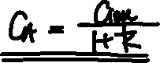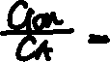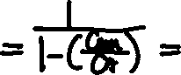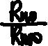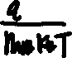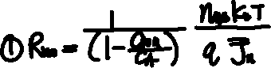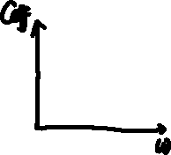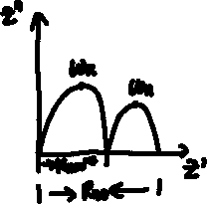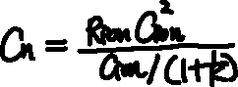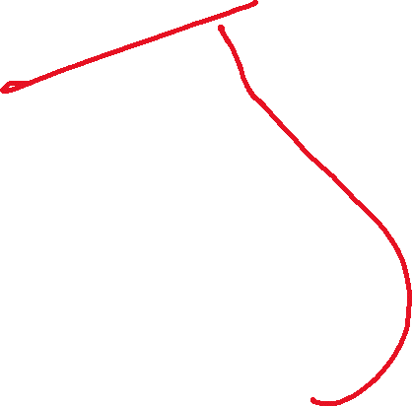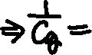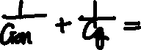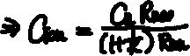

By implementing the second initial guess function, a result is obtained for C_ion. However, he result deviate from the actual value estimated: (0.00011029) vs. 1e-07.

Now try to debug:

1. The old loglog plot is not working because the value of the function goes below 0, couldn’t be shown on the plot. By adding 1 to the function and find its crossing with line 1, the solution can be shown graphically.
   1. Chart, histogram

      Description automatically generated
2. It is verified that the points R_n8 , R_n0 , w_n , w_t , C_G,w_r found from the plot directly is correct.
3. Now try use matlab file to see from another angle

The problem is found that the formula for w_t seems to be wrong. For the simulated data, the w_theta by formula should be 0.0334 but the maximum of phase and the minimum in Nyquist plot gives the frequency of ~0.88.

The formula being

* By doing the derivation by myself, the formula is obtained to be
* w = A picture containing chart

  Description automatically generated, having same numerical result as the original formula
* Investigating the plot of the theta vs. frequency:
  + np.angle(np.conjugate(df['impedance']) givesChart, line chart

    Description automatically generated
  + np.angle(-(df['impedance']) gives Chart

    Description automatically generated(corresponds to paper)
  + -np.angle((df['impedance']) givesChart, line chart

    Description automatically generated

# WEEK 9

Task list:

1. Revise the initial guess finding function to be:
   1. ~~The value of R_ion is guessed by the user and the other parts are calculated using the formulas on the paper correspondingly ;C_G is used as initial guess as C_g~~
   2. Maybe try to solve for the analytical solution of the w_theta to get the values direct.
   3. ~~Make the R_ion guess to be inputted by a slider and plot the result of putting the initial guess into the model. Also make sliders for each of the elements of the initial guess for the user to adjust the initial guess freely~~
2. General functional improvements
   1. ~~Add data box to directly define the initial guess manually~~
   2. Add ticks to let user fix a certain parameter
   3. Make the curve fit to be weighted
   4. ~~Customize the range for each slider~~

Progress

1. By letting the user guess the R_ion, the new version of the initial guess finding algorithm managed to work with considerable accuracy.
   1. By using the R_ion given in the paper (6.7 e4), the Nyquist plot of the initial guess directly without doing the fit is obtained to be : Diagram

      Description automatically generated with medium confidence
   2. In order to test the sensitivity of the plot to the R_ion value, the R-ion is guessed to be 1e4 and 1e5 respectively and giving the following fit.
      1. Venn diagram

         Description automatically generated
      2. Chart

         Description automatically generated
      3. Chart

         Description automatically generated
   3. Therefore, it could be shown that the shape of the Nyquist plot is not very sensitive to the value of the R_ion. With the help of adjustable slider, the user should be able to obtain a reasonable guess of the R_ion quickly.
2. Adding sliders to adjust the initial guess.
   1. I feel like it would be better to first adjust the R_ion only and then adjust the rest respectively.
   2. The slider for R_ion only and all parameters are implemented and working right now. However, the code can only be used by running cell by cell because the plots and sliders pop out together. Need to figure out a way to make them sequential.

Task for 8.31:

1. ~~Add legends~~
2. ~~Add bode/ angle plots~~
3. ~~Add data box?~~

Task for 9.1

1. ~~Adjust the range of slider for parameters~~
2. ~~Added data box and so on~~
3. ~~Add subplots to the comparison plot~~
4. Add fix value for the global fit

Task for 9.2

1. ~~Add fix value for the global fit~~
2. Clean up the code

ADDING fix value:

1. In order to fix, I used another package lmfit.model to do the fit and the fit without fixed variables is obtained to be: Diagram

   Description automatically generated
2. Then the fixed fit is achieved by setting the boundary to be very narrow.
   1. Comparison: without any fixed parameters: Chart

      Description automatically generated with medium confidence
   2. Fixing[CA CB Rion] Histogram

      Description automatically generated



* 1. Fixing all: A picture containing graphical user interface

     Description automatically generated

Next step, clean up the code to use C_ion

1. Next step:
   1. ~~Adjust the position of the tickbox~~
   2. ~~Make the functions to be about C_ion~~
   3. Make a global fit with changing C_A
   4. Maybe make the plots to be functions

WEEK 9

# Tasks

1. ~~Use the interactive botton on the plot to directly go to the next step instead of cell by cell~~
2. ~~Add max sample plot~~
3. Obtain another fitting algorithm for the 0V case.
   1. Failed
4. Do a global fit with changing C_A and C_ion
5. Check with more general simulated data

* Doing the global fit
  + If consider V = 0 case, the global fit deviates a lot, but when only considering the other sets of data, the fit is working fine
  + Now need to do:
    - ~~visualize the fitting for the global fit~~
    - add weighting to the fit.

# Week 10

Tasks:

1. add the series resistor
2. add the shunt resistor
3. do the data cleaning first
4. do the option selection menu and do the corresponding adjustment.
5. Add the other method of finding Js andn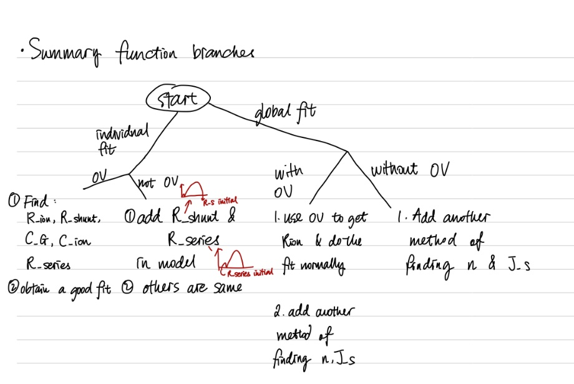

2022.9.13

1. Tring to add the series and shunk resistor to the model.
   1. The initial guess algorithm for the series resistor needs to be implemented as well
      1. Need to write different versions of initial guess finding algorithms
      2. Now write initial guess finding algo for the 0V individual.
         1. Remember to revise the not 0v initial guess algo
         2. Change the first max sample plotA picture containing calendar

            Description automatically generated
         3. Change the finding end plot
         4. Remember freq from big to small
   2. Finding R_srs by 0V case gives a negative number. Normal when other cases.
   3. Change vbi to be only one value
   4. don’t need vbi for not 0V individual case.
   5. Global fit giving not reasonable fit